To the Glory of God

A Collection of Hymns
Etc.

Written or Updated by

Rev. Mark S. Willig

If you wish to use these hymns they are posted on our congregation’s web site.
FICLC.org. Look for “Pastor’s Hymns”.
They are JPG images so they can be inserted as you would a picture,
and then enlarged to fit.
There is no cost. But please include the copyright information.

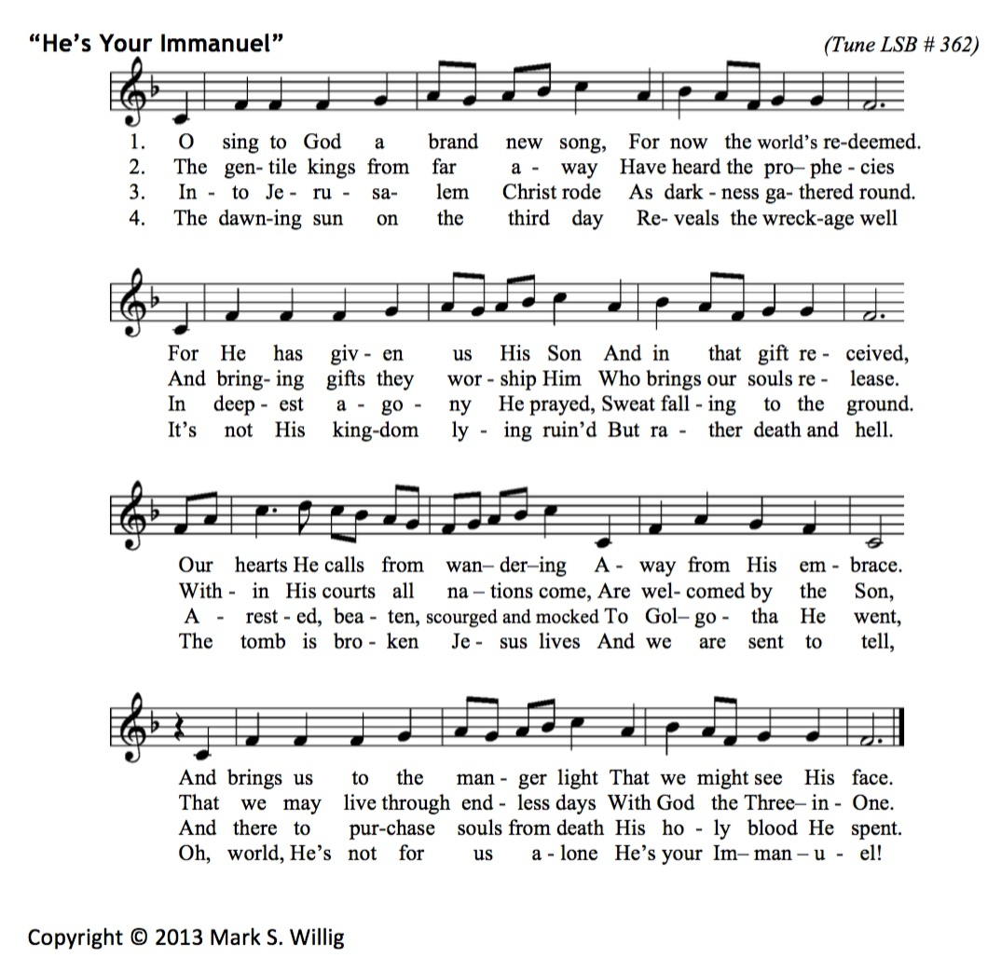

-1-
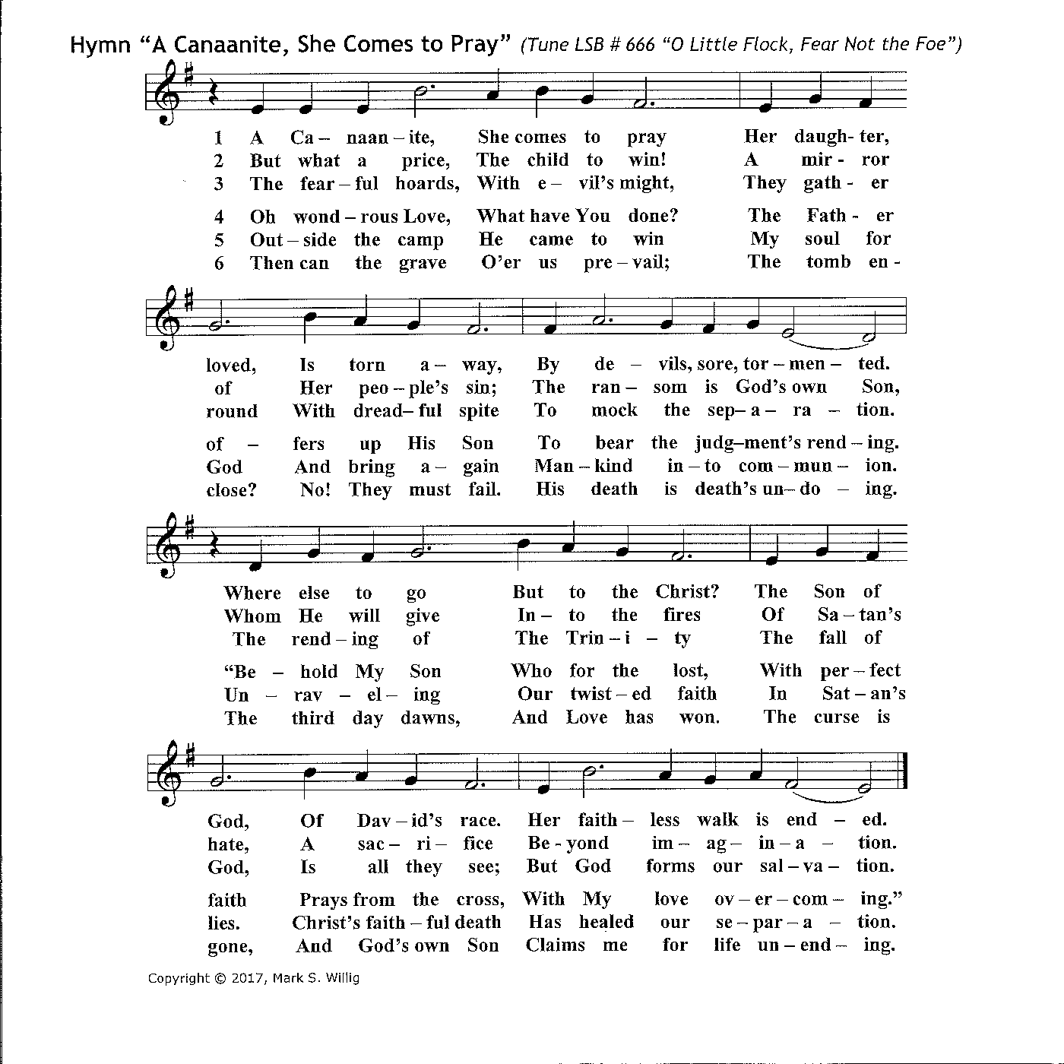

-2-
Hymn “Come, Mary, Gaze Into the Tomb” (Common Version – Tune LSB # 455)
-3-
Hymn “Come, Mary, Gaze Into the Tomb” (Messianic Jewish Version – Tune LSB # 455)
-4-
6. I eat, amazed at Jesus’ grace. 7. Lord Jesus Christ, by word and meal,
In silent awe I pray, Sustain us by Your grace,
“What can I say to thank You, Lord?” That we before Your throne may kneel,
My words all fade away, And see You face to face,
As on that Glorious Day.* And see You face to face.

*Revelation 8:1

© 2016 Mark S. Willig

-5-
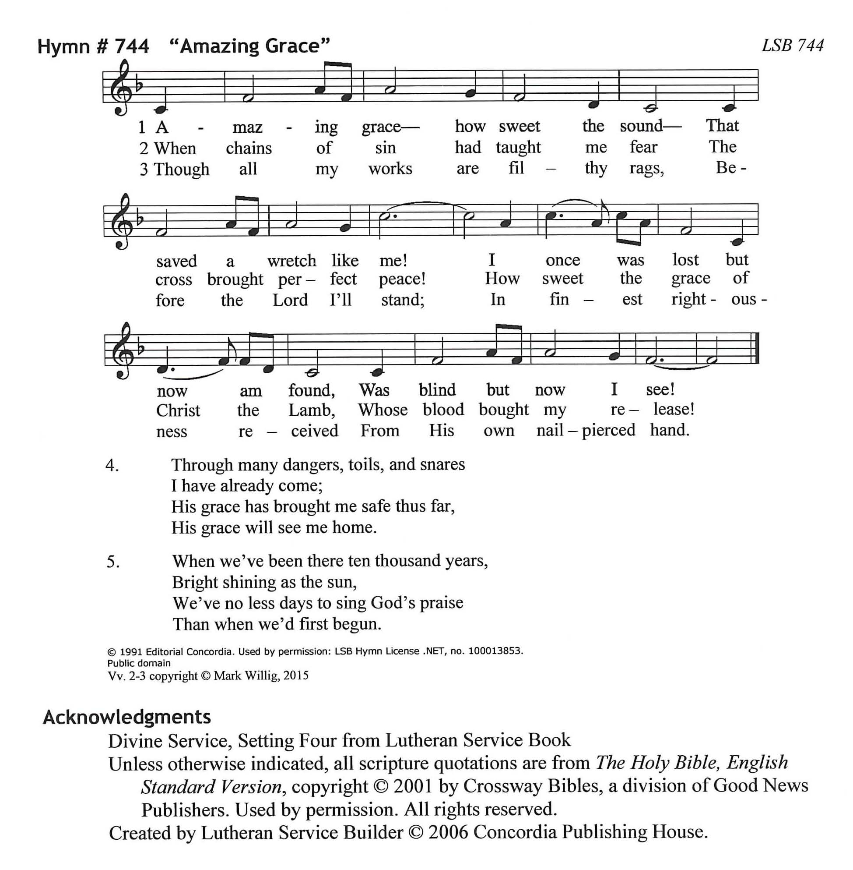

-6-
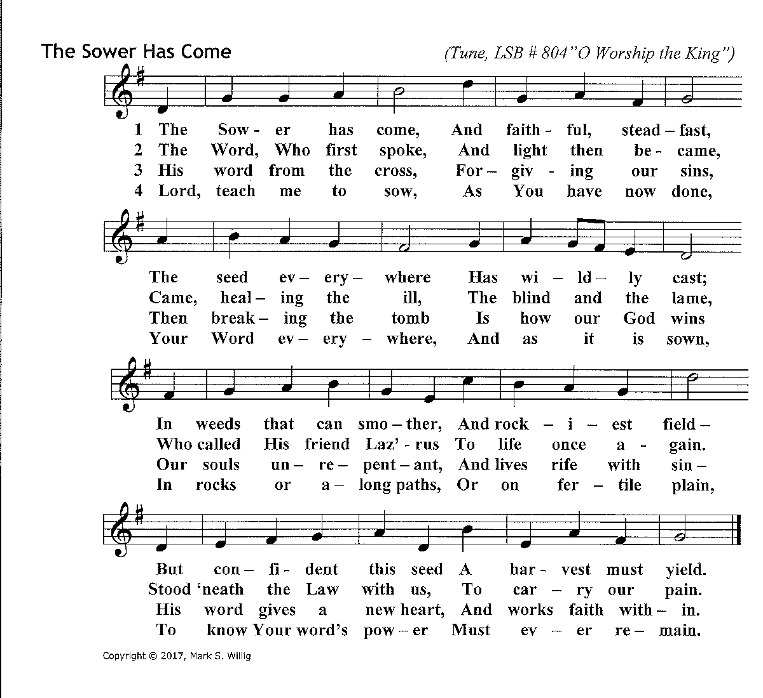

-7-

-8-
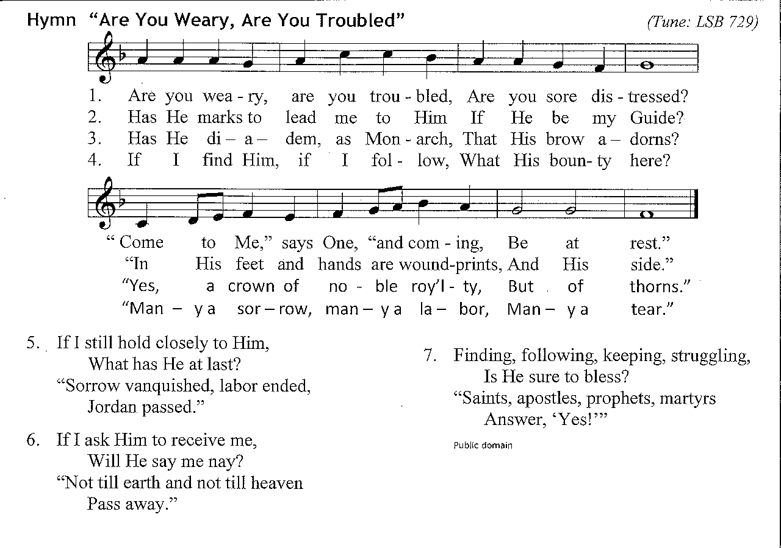
6. If I ask Him to receive me,
Will He turn away? Public Domain
“He will bring me to the realms of
Endless day.”

Updated from TLH # 513 “Art Thou Weary, Art Thou Troubled”

-9-
Hymn # 670 “Ye Watchers and Ye Holy Ones” LSB 670 sts. 1, 3
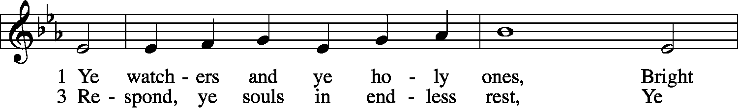
5 Un – til that day we hear His voice, Who
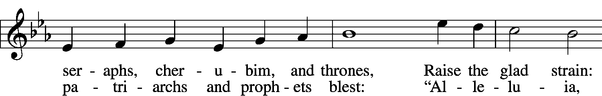
prayed for us up - on the cross, Al – le – lu – ia,
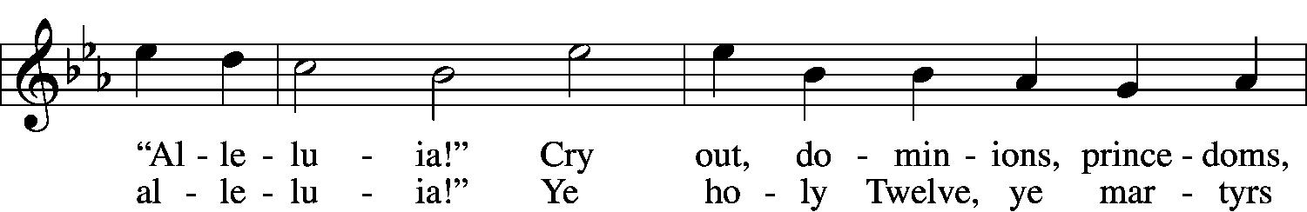
al - le – lu – ia! Ex – ult – ing in His Church set
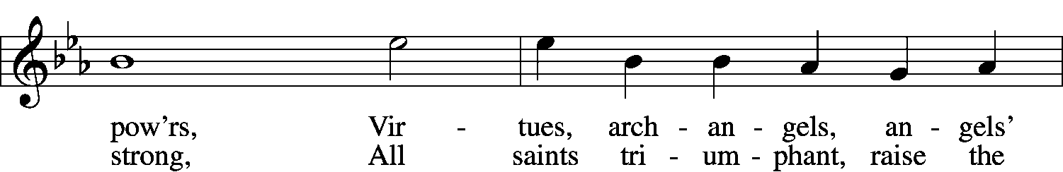
free, Sing - ing sal – va – tion’s vic - to -
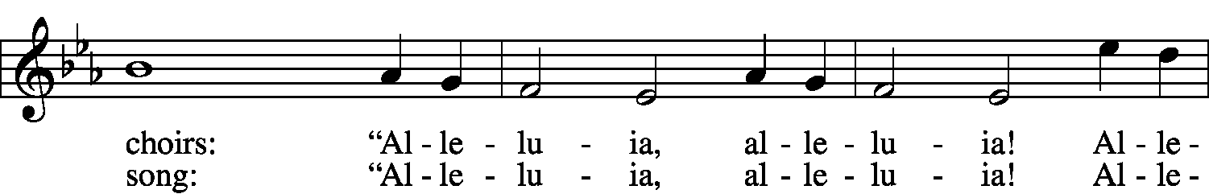
ry! “Al - le - lu - ia, al – le - lu - ia! Al - le -
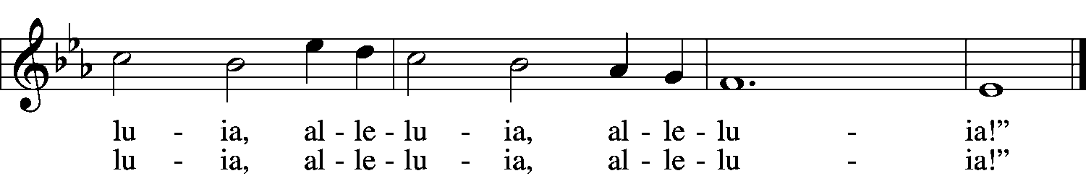
lu - ia, al - le– lu - ia, al - le - lu - ia!”
Public domain
v. 5 Copyright © 2015 Mark Willig

-10-

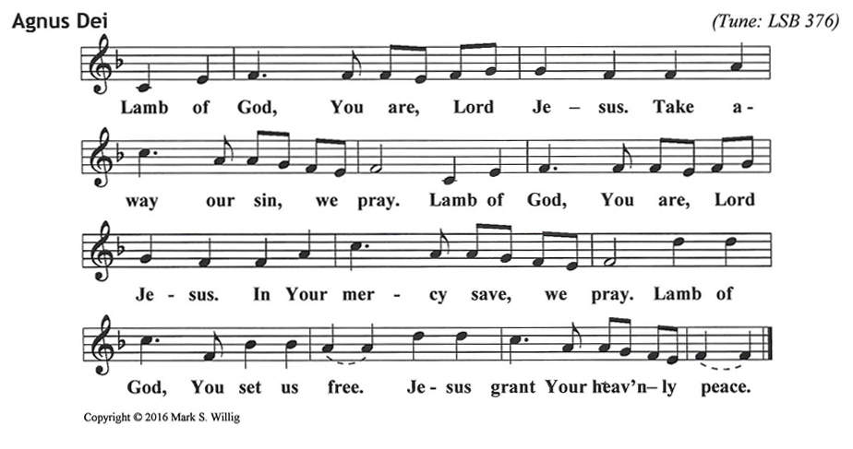

-11-

